

***Lebanese International University***

***School of Engineering***

**Department of** Computer and Communication Engineering.

**CENG375—** Data Base.

**Section ID:** A.

Final Project.

**Project Title:** Hospital Management System

**Submitted by:** Charbel Srour 52030290

Gemma Elia 51930562

Teddy Nohra 52030362

Fawzy Ghazawy 52030655

Farah Al Mazaal51930396

**Instructor:** Dr. Hadi Noureddine.

**Date: 22/4/2022**

1. **Description:**

 The Hospital management system (HMS) is a database design used for managing hospital functions and events. HMS also improve interactions between patients and their doctor. The software takes care of all the requirements of an average hospital and is capable to provide easy and effective storage of information related to patients that come up to the hospital. It provides the problem details including medical records, date of examination.

Each doctor is working in 1 hospital or not and each hospital has many doctors. Each doctor gives an appointment to many patients and vice versa. The patients may have many medical record, but this medical record belong to exactly one patient. The patients can enter 0/1 hospital and the hospital has many patients.

1. **E/R diagram:**

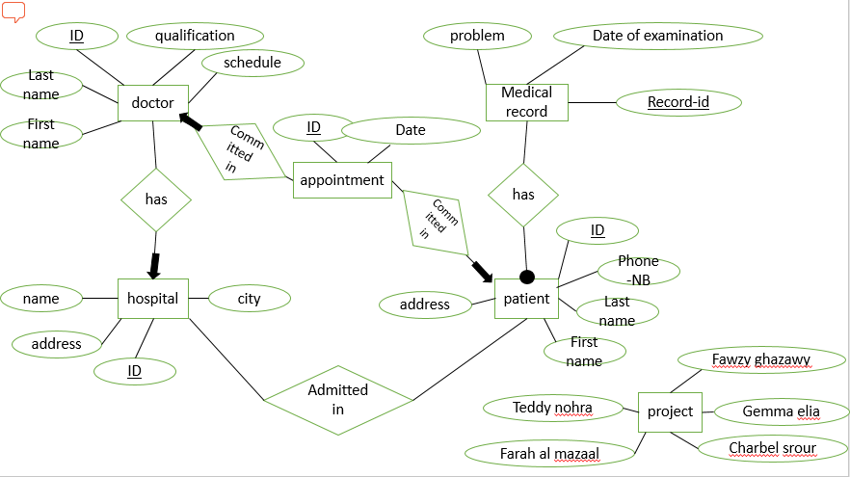

1. **Tables: (ER-mapping):**

Patient (ID, First name, Last name, Phone-Nb, Address)

Medical Record (Record-ID, Problem, Date of Examination, Patient -ID)

Doctor (DOCTOR-ID, First name, Last name, Qualification, Schedule, HOSPITAL -ID)

Hospital (HOSPITAL-ID, HOSPITAL-Name, HOSPITAL-Address, City)

Appointment (Appointment -ID, date, Patient –ID, Doctor-ID)

Admitted in (HOSPITAL-ID, Patient -ID)

1. **Queries:**
2. 1-Find the total number of doctor in specific Departments.
3. 2-Find the total number of all patient in specific city.
4. 3-Find the patients ID that have the same address of the hospital.
5. Change the Address of the patient by ID.  
   Add a new record to the Medical Record of any patient By his ID .
6. Find the ID of the doctor of any patient by his ID.
7. Change the Schedule of the Doctor by Hospital ID.
8. Find all the appointments of the doctor by his ID.
9. Find the name of the Hospital that is in a specific city ‘koura’.
10. Find the medical report of patient by his ID.
11. Cancel the Appointment of the Patient by his ID using his doctor ID.